**Chuanr Chef** texture requirements!

Thank you so much for helping with the textures. We loved your work online and we’re really excited to see how much better the game looks once it has an artistic touch :D

Here’s a screenshot from the current game:

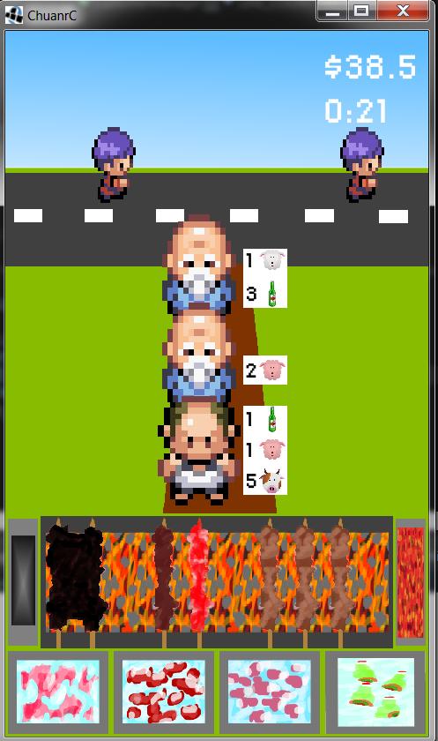

**Game description:**

Android game marketed in China. You operate a street grill where you cook a type of Chinese kebab called “Chuanr.” The setup looks something like this: <http://waiguorenornot.files.wordpress.com/2011/08/beijing_chuanr_cooking.jpg>

You cook different types of meat (chicken, beef, or lamb) and serve your hungry customers!

The bottom area is the grill. The different meat (chuanr) on the grill are burnt chicken, cooked beef, raw beef, and three cooked lambs. To the left of the grill is the Trash, to the right is the Spice box.

Below the grill are the four **ice chests**: chicken, beef, lamb, and beer.

**Backgrounds**(5 different areas, 2 static images each):

- Each should be 960x720 resolution (4:3)

- Each should have some kind of road/path/sidewalk around 4/5 of the way up the screen (see example backgrounds)

- Everything on the lowest third of the screen will be covered by the grill, so don't worry about filling that in.

- There are two types of backgrounds, one queue line and two queue lines. If you could make both 1 and 2 line versions for each background that would be ideal.

- See the example background images attached for the exact layout

- Dan has sent you 5 images for each of the different areas we need backgrounds for (Village, Outskirts, Suburbs, University, Central Business District).

- Here are some details for each area:

* Village:
* Outskirts:
* Suburbs:
* University:
* Business District:

Here’s the two basic layouts for the backgrounds:

**One path: Two Paths:**

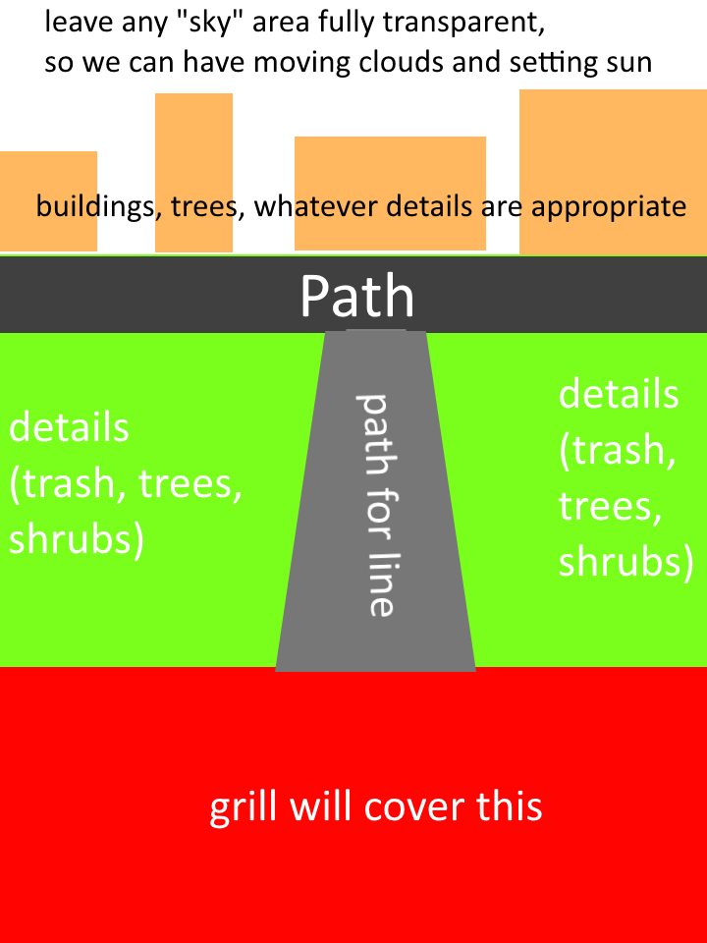 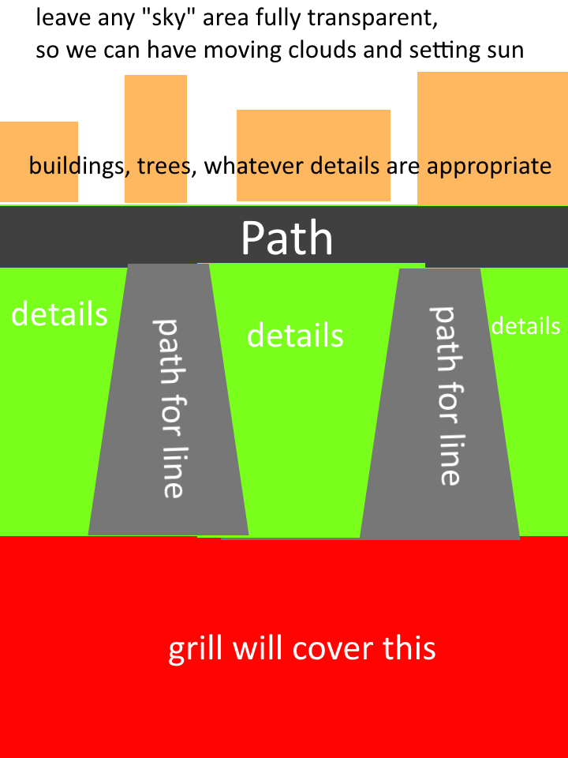

**Customers (7 customer types with 4 sprite sheets each = 28 sheets):**

* There are seven types of customers who will be ordering at the stand
* Each customer should be at least 160x160 (although higher res options would be nice to have)
* We want them to be as squarish as possible without looking flat. So far we’ve been using people from pokemon as replacements, and they’re the perfect width/height ratio (a little bit taller than square).
* Each customer type will need several sprite sheets:
  + Walk right (2 frames)
  + Walk down (2 frames)
  + Walk up (2 frames)
  + Face down/waiting (2 frames)
    - One frame is just the customer facing down.
    - We also want an additional “idle” frame for when a customer is waiting for a long time (ie, checking their watch, scratching their head, crossing their arms). You can decide for each customer type what would be a good idle
  + (Later on, we’ll need customer puking)
* The seven customer types are:
  + Normal man (regular dark haired Chinese guy)
  + Normal woman (regular dark haired Chinese woman)
  + Old man (hands behind back, white beard, bald)
  + Old woman (hands behind back, white/gray hair)
  + Foreigner/tourist (pudgier than the others, maybe with a camera)
  + College student (backpack, button down shirt, maybe glasses)
  + Businessman (suit and tie, maybe glasses, briefcase, etc)
* For some basic examples see the attached customer textures.

**Meat (3 types with 5 states each = 15 textures):**

* Chuanr is a type of meat kebab. It comes on a wooden stick and looks like this: <http://upload.wikimedia.org/wikipedia/commons/8/87/Barbecued_lamb_sticks.jpg>
* Three types of meat, Chicken (pink when raw), Beef (reddish when raw), Lamb (pink/purple when raw)
* Five states for each (raw, raw spiced, cooked, cooked spiced, burnt)
* Note that chicken uses two sticks and takes up twice as much space as beef or lamb and looks like this: <http://cwstatic.cityweekend.com.cn/files/cache/cd/80/cd8087134152d566ecb853e5e95970e5.jpg>
* Beef and lamb should be at least 100 width x 300 height
* See the sample textures for examples

**Grill (three sheets):**

* There are three grill textures: left edge, center, and right edge. This way we can have the grill be expandable by simply repeating the center section.
* Should be based on this type of grill:

<http://blog.uchinatravel.com/wp-content/uploads/2012/04/EpicChuarn_UCT.jpg>

<http://waiguorenornot.files.wordpress.com/2011/08/beijing_chuanr_cooking.jpg>

* The size for each section should be 100 (width) x 300 (height).
* The standard grill has one left piece, 8 center pieces, and one right piece.
* They should be on a two frame animation (with embers burning)

**Ice chests (4 total):**

- We'll need 4 different ice coolers for the grill area. One for Chicken, one for Beef, one for Lamb, and one for Beer.

- Each needs to be at least 160 (width) by 180 (height)

- It would be awesome if they were drawn at an angled so you could see the label on the front of each box (a little chicken head, a little cow head for beef, see **Icons** section below) but still see the ice at the top and some of the meat.

- It works well if chicken is light pink, lamb is more purply-pink, and beef is red.

- Chinese beer bottles are green. We’d like the bottles to be based off the beer called **Tsingtao**:

<http://danmurphys.com.au/media/DM/Product/750x2000/907131_0_9999_v1_m56577569852044540.jpg>

**Icons and Misc**

* We’ll need 4 very small icons to represent Chicken, Beef, Lamb, and Beer. See the textures.zip for examples of what we’re using so far. These can be the same icons that
* We’ll also need a small “star” icon for restaurant reputation (5 stars, etc)